RESEARCH ANALYSIS: TEI and Git in ParlaMint

Please select a partner country you represent: (Q1) / Have you used Git as part of ParlaMint I+ II projects? (Q11) (Crosstabs - Chart)
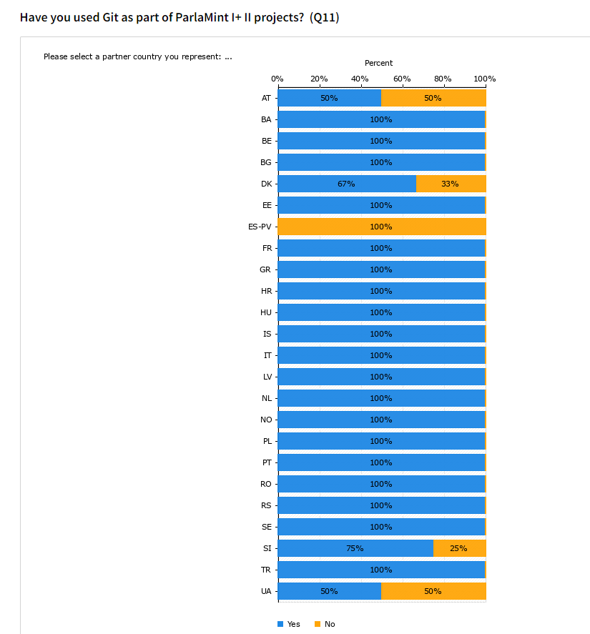

Diagram displaying the usage of Git for each partner country

What is your background? (Q4) / Do you have previous experience with version control systems like Git? (Q6) (Crosstabs - Chart)

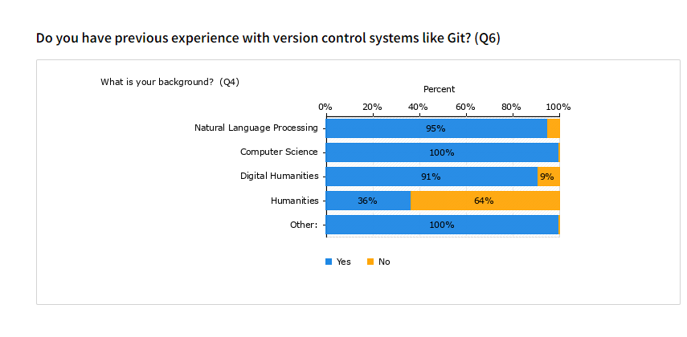
Diagram showing experience compared to the background of the project partners

What is your background? (Q4) / How familiar were you with the TEI P5 Guidelines or TEI in general before you started working on ParlaMint? (Q26) (Crosstabs - Chart)

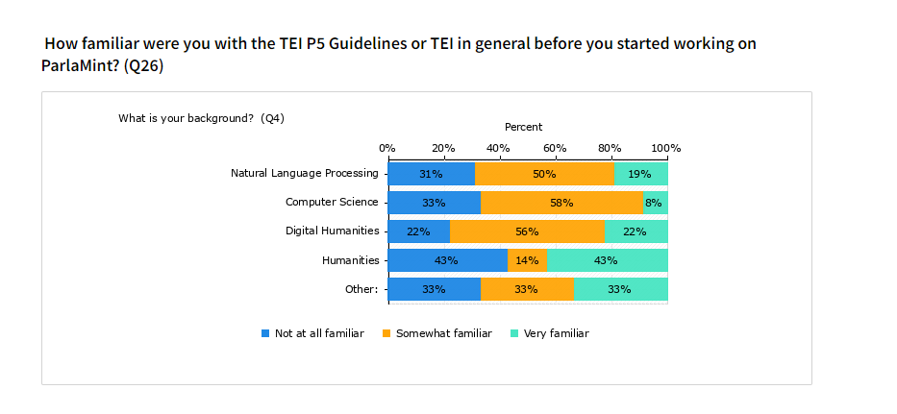
Diagram showing familiarity with TEI based on the research backgrounds

Git workflow and Issues (Q23) / Did you create a GitHub issue to discuss any issues you encountered? (Q12) (Crosstabs - Chart) 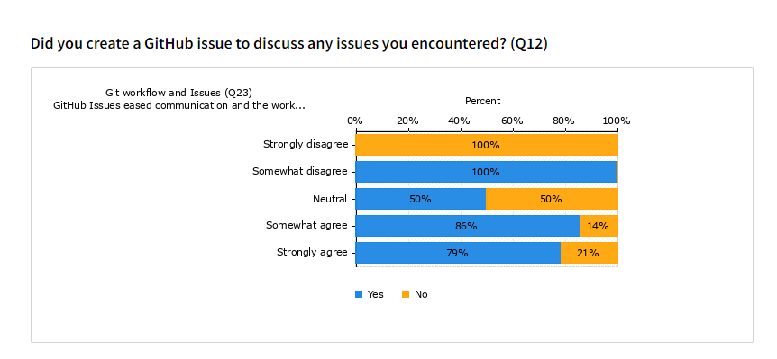
Diagram showing the relationship between the creation of an GitHub Issue and the opinion that Issues eased communication on a project

How familiar were you with the TEI P5 Guidelines or TEI in general before you started working on ParlaMint? (Q26) / I plan on using TEI for my future work (Q29e) (Crosstabs - Chart)
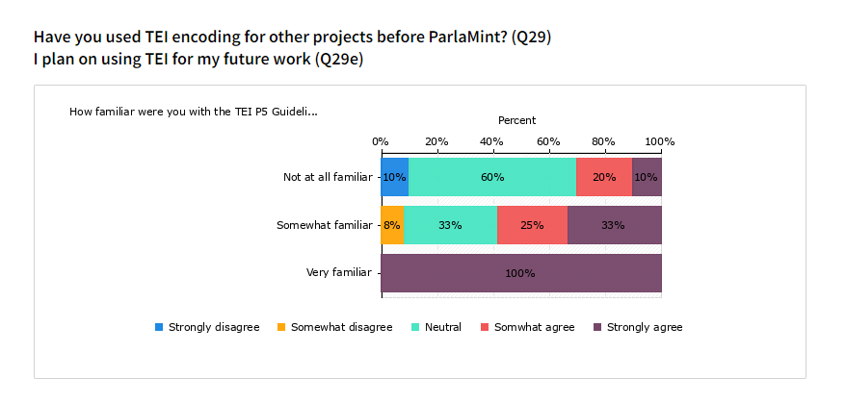

Diagram showing relationship between familarity with TEI at the beginning of the project work and the assesment on whether participants plan on using TEI in their future work

What was your experience: (Q8) / The acquired knowledge about Git will be useful for my future work (Q23g) (Crosstabs – Chart)
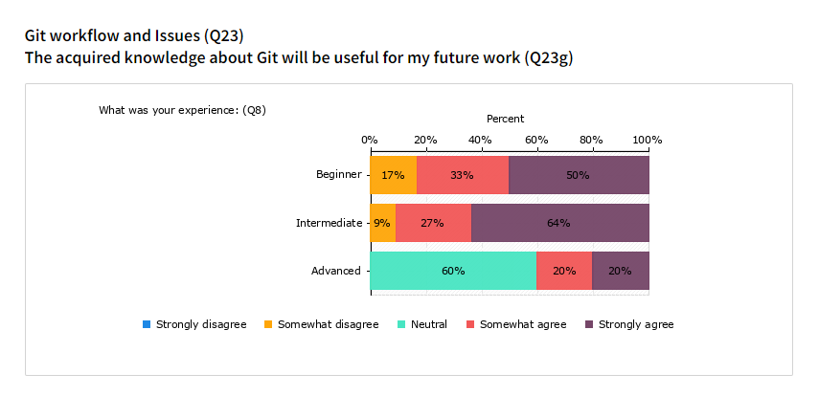

Diagram showing the relationship between the level of experience at the beginning of the project work and the assessment of whether the knowledge acquired will be useful to the participants in their future work.

What is your background? (Q4) / I plan on using TEI for my future work (Q29e) (Crosstabs – Chart)

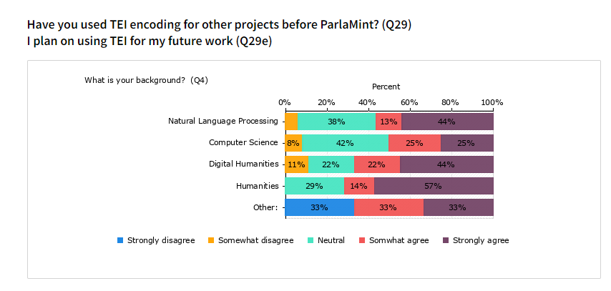
Diagram showing the relationship between research background and the assessment of whether the participants plan on using TEI in their future work.

What is your background? (Q4) / I plan on using Git for my future work (Q23h) (Crosstabs – Chart)
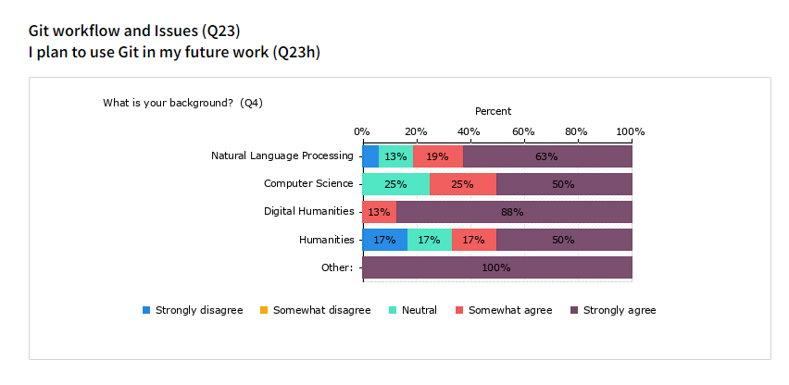
Diagram showing the relationship between research background and the assessment of whether the participants plan on using Git in their future work.

